Figure 1: Overall survival probability and its 95%-confidence interval for each timepoint estimated by Kaplan-Meier approximation split by the IRSS staging of the retinoblastoma. If the parents did not mention the date of death, the date 6 months after the last appointment at NEC was considered the estimated time of deaths.

Table 1: 1- and 3-year overall survival rate and 95%-confidence interval (CI) of all patients diagnosed with retinoblastoma between 2017 and 2021, estimated by a Kaplan-Meier approximation. If the parents did not mention the date of death, they are censored at the last appointment at NEC. Some confidence intervals could not be calculated due to missing sample size.

|  |  |  |  |  |
| --- | --- | --- | --- | --- |
|  | | Median survival (95%-CI) | 1-year rate (95%-CI) | 3-year rate (95%-CI) |
| **IRSS Staging** | 0-I | NA (NA, NA) | 0.667 (0.300, 1.000) | 0.667 (0.300, 1.000) |
| II | 4.30 (2.77, NA) | 0.876 (0.809, 0.947) | 0.574 (0.458, 0.718) |
| III | 1.88 (1.31, NA) | 0.779 (0.608, 0.999) | 0.256 (0.055, 1.000) |
| IV | 1.42 (1.06, NA) | 0.875 (0.673, 1.000) | 0.000 (NA, NA) |
| Total cohort | | 3.69 (2.5, NA) | 0.856 (0.797, 0.920) | 0.535 (0.431, 0.664) |

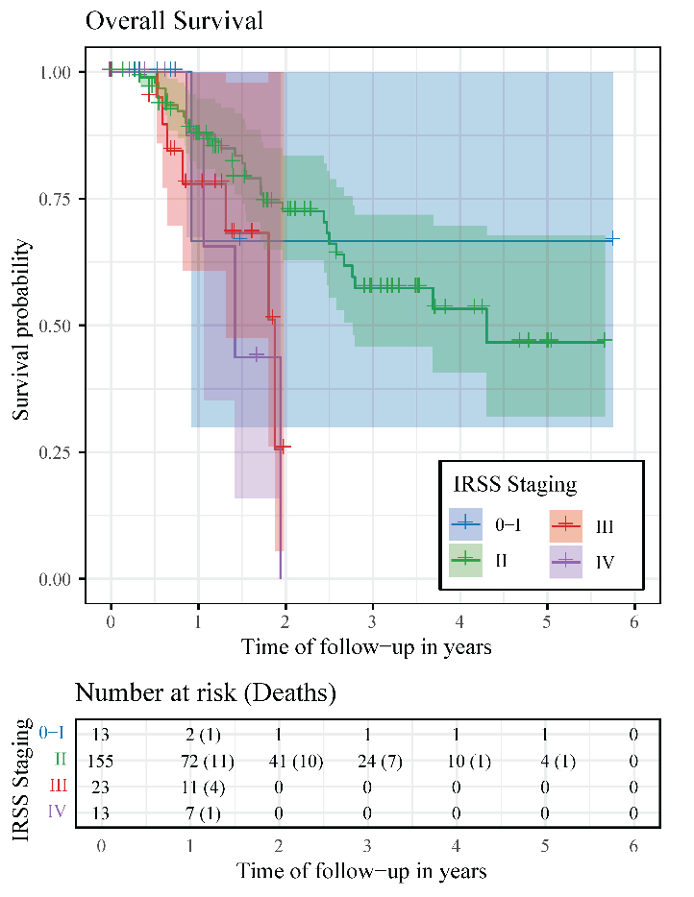

Figure 1: Overall survival probability and its 95%-confidence interval for each timepoint estimated by Kaplan-Meier approximation split by the IRSS staging of the retinoblastoma.